Лабораторная работа №2

ИССЛЕДОВАНИЕ УСИЛИТЕЛЬНЫХ ЭЛЕМЕНТОВ.

1. Исследование биполярного транзистора

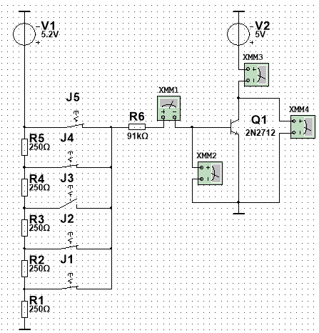

|  |  |  |  |  |  |  |  |
| --- | --- | --- | --- | --- | --- | --- | --- |
| Uкэ | 0.3 | 1 | 3 | 5 | 7 | 10 | В |
| Iк1(IБ1) | 0.449 | 0.457 | 0.473 | 0.489 | 0.504 | 0.528 | мА |
| Iк2(IБ2) | 1.681 | 1.711 | 1.770 | 1.830 | 1.887 | 1.979 | мА |
| Iк3(IБ3) | 3.007 | 3.064 | 3.170 | 3.276 | 3.383 | 3.542 | мА |
| Iк4(IБ4) | 4.363 | 4.451 | 4.604 | 4.759 | 4.913 | 5.144 | мА |
| Iк5(IБ5) | 5.732 | 5.853 | 6.055 | 6.258 | 6.461 | 6.764 | мА |

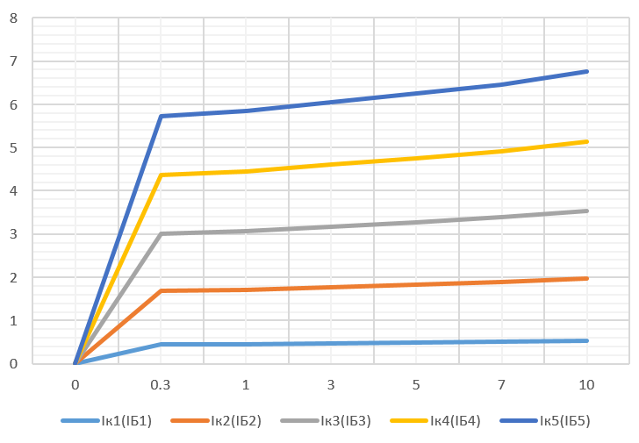

Β = ∆Iк / ∆IБ при Uкэ = 5В

Β = (1.830 - 0.489) * 10-3 / (15.987 - 4.885) * 10-6 = 120.789

rвых = ∆UКЭ / ∆IК при Iб = Iб3

rвых = (7 - 3) / (3.383 – 3.170) * 10-3 = 18.779 кОм

IБ = f (UБЭ) при UКЭ = 5 В.

|  |  |  |  |  |  |  |
| --- | --- | --- | --- | --- | --- | --- |
|  | Iб1 | Iб2 | Iб3 | Iб4 | Iб5 |  |
| Iб | 4.885 | 15.987 | 27.200 | 38.525 | 49.960 | мкА |
| Uбэ | 0.588 | 0.622 | 0.638 | 0.648 | 0.656 | В |

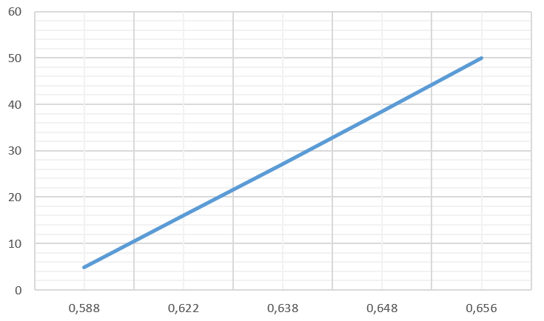

rвх = ∆UБЭ / ∆IБ  при Iб = Iб(2/4)

rвх = (0.648 – 0.622) / (38.525 – 15.987) * 10-6 = 1.154 кОм

2. Исследование полевого транзистора с p–n затвором

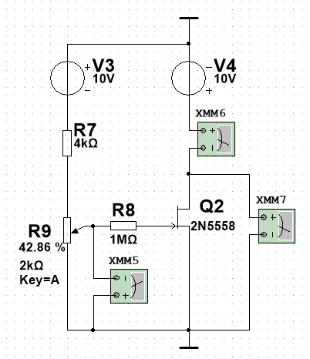

2.2.

IС = f (UЗИ) при UСИ = 5 В

|  |  |  |  |  |  |  |  |  |
| --- | --- | --- | --- | --- | --- | --- | --- | --- |
| Uзи | 0 | 0.5 | 1 | 1.5 | 2 | 2.5 | Uотс= 2.886 | В |
| Iс | Iс.нас=7.524 | 5.165 | 3.247 | 1.771 | 0.738 | 0.150 | Iс = 0 | мА |

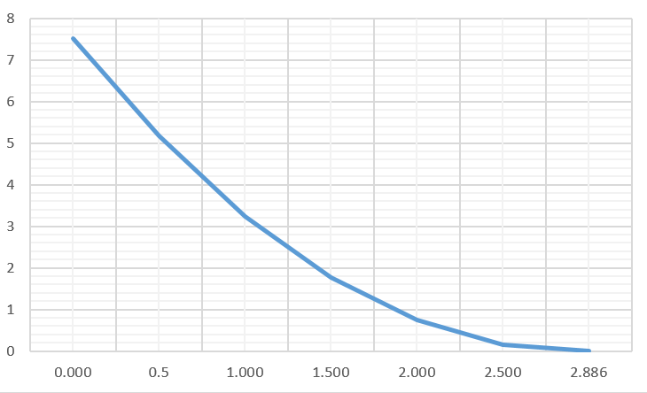

2.3.

S= ∆IС / ∆UЗИ

SМИН = |(0– 0.15)| / (2.886 – 2.5) = 0.389 (мА/В)

SМАКС = |(5.165 - 7.524)| / (1 – 0.5) = 4.718 (мА/В)

2.4.

UЗИ = 0

Uотс = Uотс / 2

IС = f (UСИ) при UЗИ = const

|  |  |  |  |  |  |  |  |  |
| --- | --- | --- | --- | --- | --- | --- | --- | --- |
| Uси | 1 | 2 | 3 | 4 | 6 | 8 | 10 | В |
| Ic  (Uзи = 0) | 4.157 | 6.645 | 7.426 | 7.474 | 7.573 | 7.670 | 7.768 | мА |
| Ic  (Uзи = Uотс/2) | 1.677 | 1.880 | 1.893 | 1.906 | 1.930 | 1.955 | 1.981 | мА |

